Contents

1 Project Folder Structure and Instructions 1

1.1 Folder Structure 2

1.2 System Log File 3

2 User Manual 3

2.1 Prerequisites 3

2.2 Step-by-Step Instructions 3

# Project Folder Structure and Instructions

This document provides an overview of the project folder structure and instructions for running the application.

⚠️ **Important:** Extract the zip folder directly at the root of a drive (e.g., C:/, D:/) **or** use **7-Zip** to extract the folder.

* Extracting at the root helps avoid path length issues. 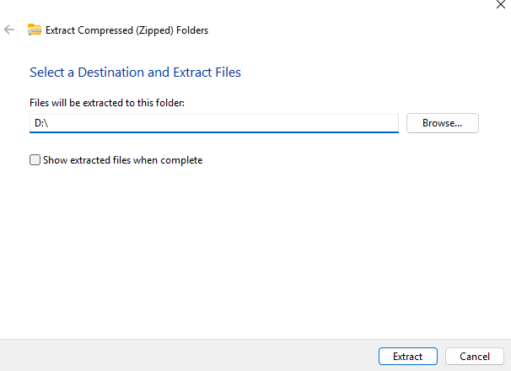
* If you use **7-Zip**, you **do not need** to extract directly at the root of the drive, as it can handle long paths.

If not extracted properly, the application may encounter issues such as:

1. **Path Too Long Error** – Windows has a maximum file path length limit (typically 260 characters), which can be exceeded if the folder is nested too deeply.
2. **Missing File or Resource Errors** – Some dependencies or internal files may not load correctly if paths are broken.

## Folder Structure

1. **Source Code/**

This folder includes all the source code for the main application:

* + **Frontend** – the user interface of the trading app.
  + **Backend** – the API and core business logic.
  + **Database** – local database integration for storing and retrieving data.

1. **TrainModelCode/**

This directory contains code and scripts to train the AI model used by the trading application.

1. **windows-app/**

This folder contains the packaged Windows version of the application.

Inside this folder, you'll find the Auto Trade application:   
C:/ └── CHIN WEI MIN-TP068781-APU3F2408CS(CS)-win_AUTO_Trade/   
 └── Auto Trade.exe ← Run this to launch the application

⚠️ **Important:** If you do not extract the folder properly, it may miss some important packages or files, which will cause the entire application to stop working.

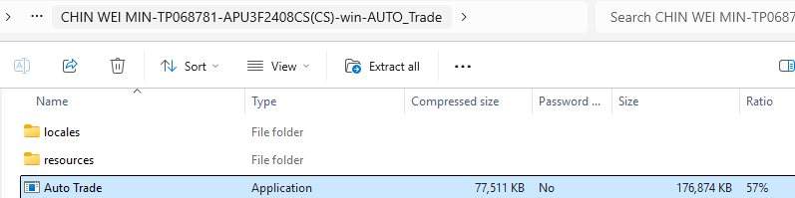

## System Log File

The application generates a log file to help with debugging and tracking system behavior.

You can find the system log at:  
windows-app/resources/app/backend/api.log

# User Manual

This user manual provides step-by-step instructions to set up and operate the AUTO Trade application for automated trading on the XAUUSD market using MetaTrader 5 (MT5). Follow these steps carefully to ensure a smooth experience. Each step includes references to figures for visual guidance and troubleshooting tips where applicable.

## Prerequisites

* A stable internet connection.
* A Windows PC (for running Auto Trade.exe).
* Basic familiarity with trading platforms and account management.

## Step-by-Step Instructions

#### Step 1: Install MetaTrader5

1. Visit <https://www.metatrader5.com/en/download>.
2. Download the MetaTrader 5 platform for Windows.
3. Run the installer and follow the on-screen instructions to complete the installation.

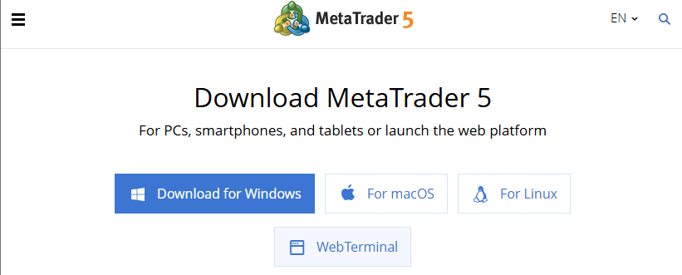

Figure 1: Download MetaTrader5 platform.

***Troubleshooting Tip****: If the download fails, check your internet connection or try a different browser. Ensure your system meets MT5’s minimum requirements (Windows 7 or later).*

#### Step 2: Register a Demo Account

1. Navigate to <https://en.octafxmy.net/>.
2. Select the option to create a demo account for MetaTrader5.
3. Fill in the required details (e.g., name, email, and preferred currency).
4. Save the account credentials (account number, password, and server) provided upon registration.

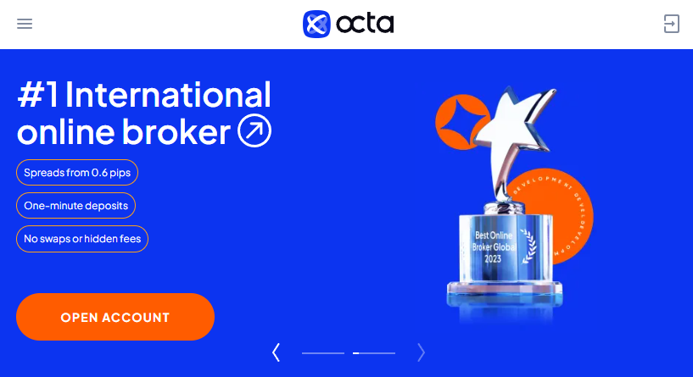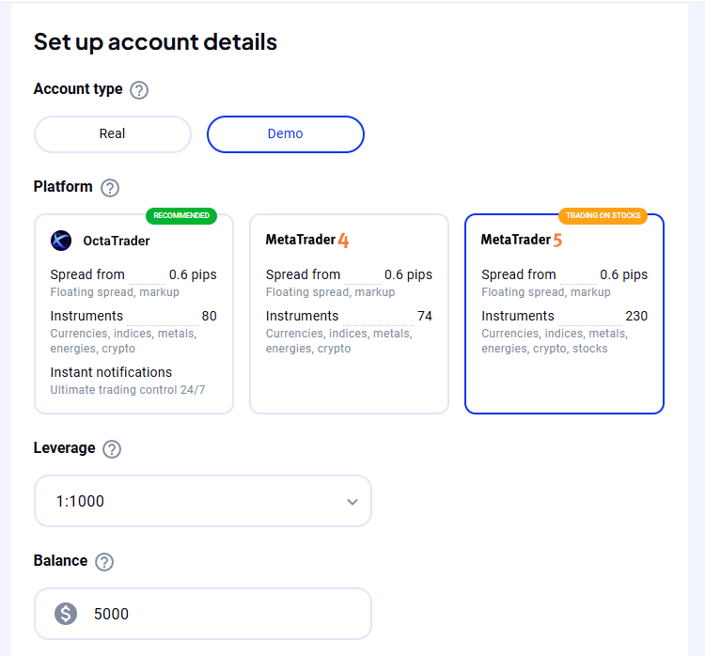

Figure 2: Create a demo account for MetaTrader5 platform.

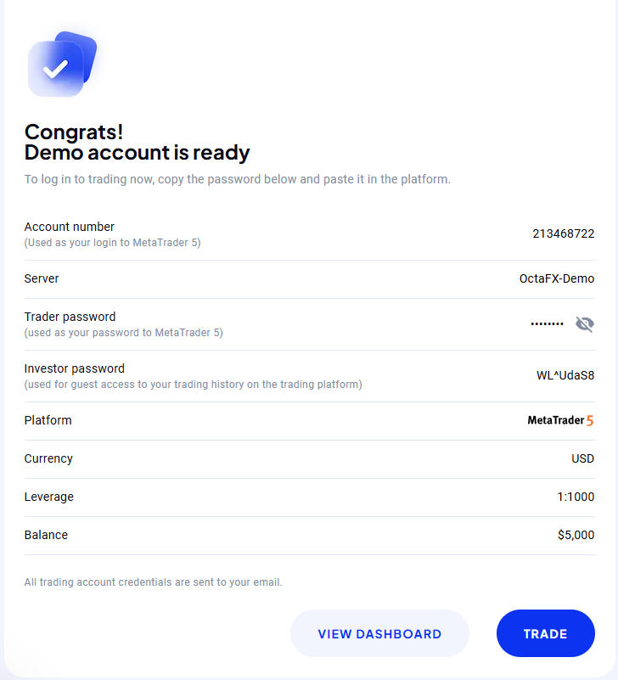

Figure 3: Save this account number, server and password to login your MT5 broker account.

***Note****: A demo account allows you to test the trading system without financial risk. Keep your credentials secure for future use.*

#### Step 3: Login to MetaTrader5

1. Launch the MetaTrader5 application.
2. Enter your demo account credentials (account number, password, and server).
3. Verify the login by checking the connection status in the bottom-right corner of MT5 (should display “Connected”).

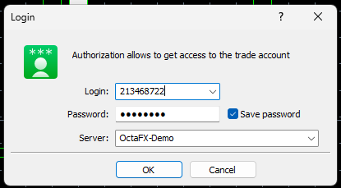 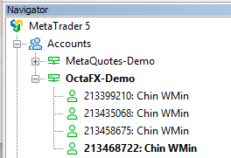

Figure 4: Login to MetaTrader5.

***Troubleshooting Tip****: If login fails, ensure the server name matches exactly as provided by OctaFX. Contact your broker’s support if issues persist*.

#### Step 4: Enable Algorithmic Trading

1. In MetaTrader 5, locate the “Algo Trading” button in the toolbar.
2. Click the button to enable algorithmic trading (the button will turn green when activated).





Figure 5: Enable algorithm trade on MetaTrader5.

***Important****: Algorithmic trading must be enabled for the AUTO Trade application to execute trades. If the run model controller button remains gray, check MT5’s toolbar to enable the ‘Algo Trading’.*

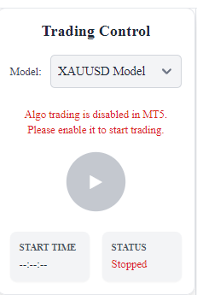

Figure 6: Run model controller will show in gray if ‘Algo Trading’ is disable.

#### Step 5: Install and Launch AUTO Trade Application

1. Download the AUTO Trade application zip file from the provided source.
2. Extract the zip file to a preferred location on your computer.
3. Navigate to the extracted folder and double-click Auto Trade.exe to launch the application.



Figure 230: Unzip folder.

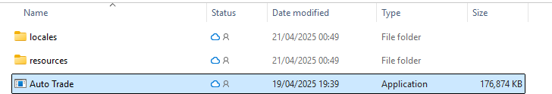

Figure 8: Double click on ‘Auto Trade’ application to open it.

#### Step 6: Sign Up for AUTO Trade

1. On the application’s startup screen, click “Sign Up.”
2. Enter a valid email address and a password.
3. Submit the form to create your account.

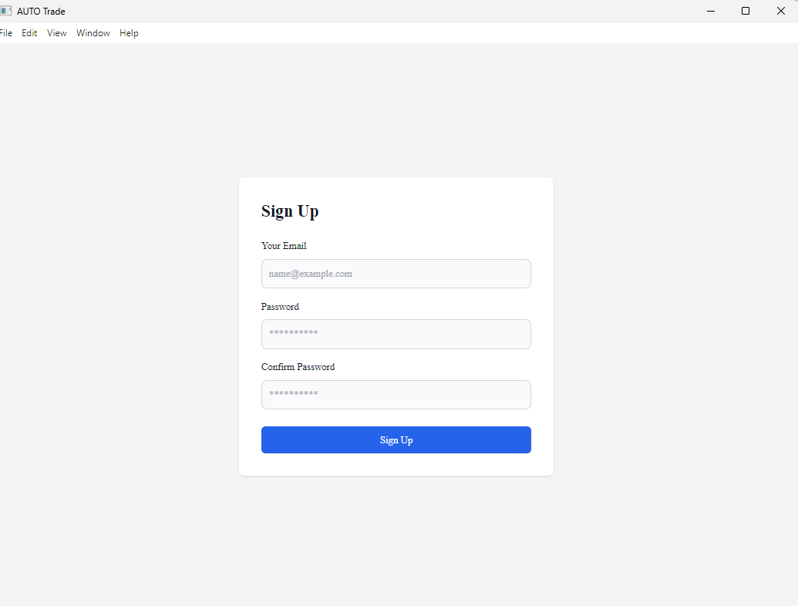

Figure 9: Frontend signup page.

***Note****: If you encounter an error (e.g., “Email already in use”), try a different email.*

#### Step 7: Login to AUTO Trade

1. Return to the login page.
2. Enter your registered email and password.
3. Click “Login” to access the application.

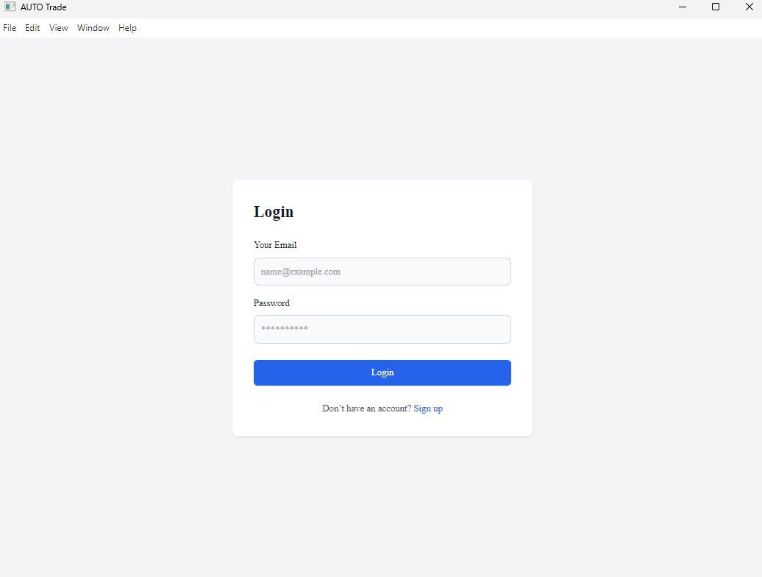

Figure 10: Frontend login page.

#### Step 8: Connect AUTO Trade to MetaTrader5

1. In the AUTO Trade application, navigate to the MT5 account setup section.
2. Enter your MT5 demo account details (account number, password, and server).
3. Optionally, check “Save Password” to securely store your credentials in the application’s database for automatic retrieval in future sessions.
4. Submit the form. If successful, MetaTrader5 will automatically open, confirming the connection.

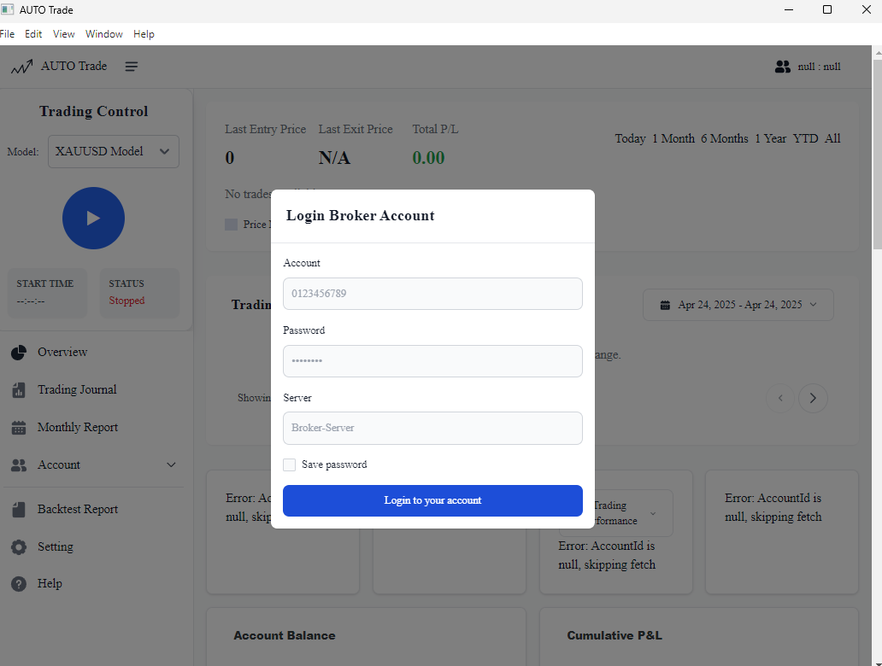

Figure 11: Fill up the detail to initial MetaTrader5 platform.

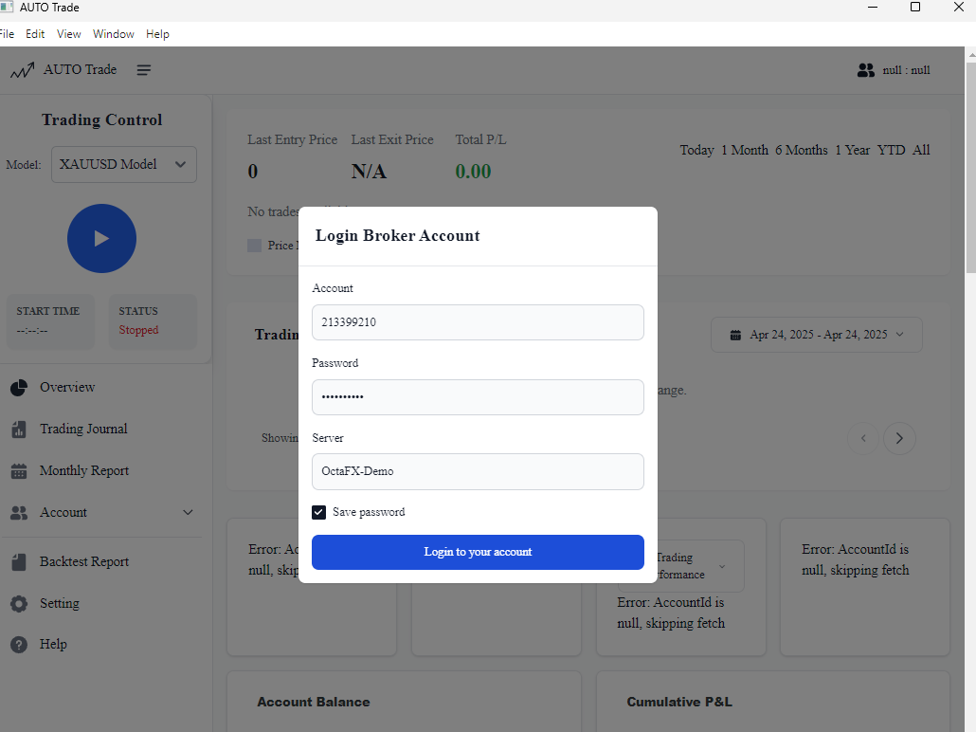

Figure 12: If ‘Save password’ checked, it will auto retrieve MT5 account detail next time.

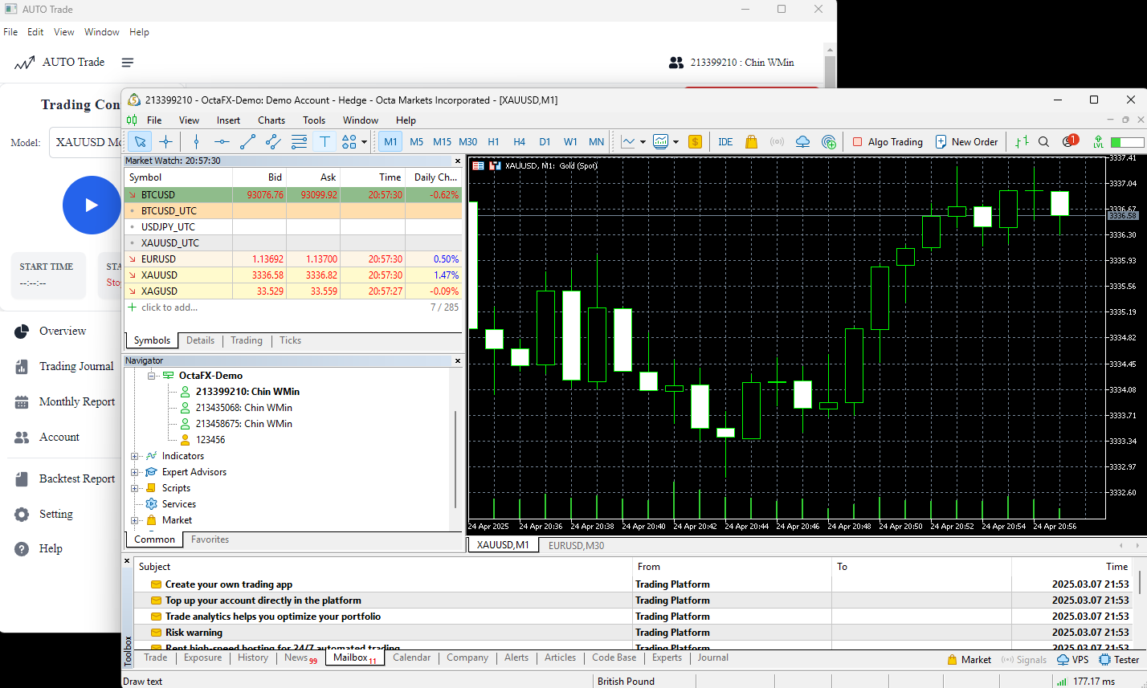

Figure 13: MT5 auto-opens after successful login to MT5 broker account.

#### Step 9: Run the AI Trading Model

1. In the AUTO Trade dashboard, locate the “Play” button for the AI auto-trade model.
2. Click the “Play” button to start the model. The status will update to “Running.”
3. To stop the model, click the “Stop” button.

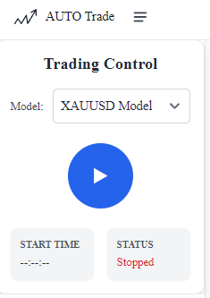 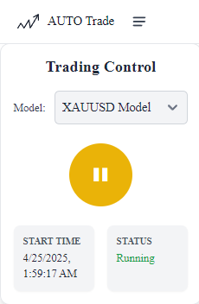

Figure 14: Run model controller stop & start.

***Note****: The AI model uses a PPO-based reinforcement learning algorithm to execute trades. Monitor its performance to ensure it aligns with your trading goals.*

#### Step 10: Monitor and Analyze Trading Performance

1. Navigate to the “Backtest Report” to review the AI model’s historical performance metrics (e.g., cumulative return, drawdown).
2. Use the “Dashboard” to view real-time trade updates, including charts and notifications.
3. Access the “Trading Journal” to track individual trade details, such as entry/exit times and profit/loss.
4. Visit the “Monthly Report” for aggregated performance statistics by month.
5. In the “Settings” page, customize trading parameters:
   1. **Symbol**: Specific XAUUSD symbol name assigned by the broker account.
   2. **Volume**: Set the trade size (e.g., 0.1 lots).
   3. **Stop Loss**: Define the maximum loss per trade in points.
   4. **Take Profit**: Set the target profit per trade in points.

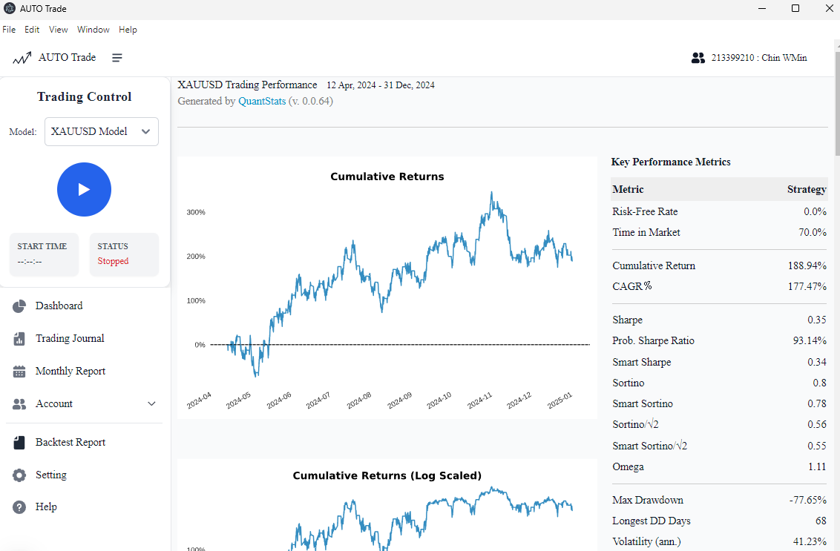

Figure 15: Frontend backtest report page.

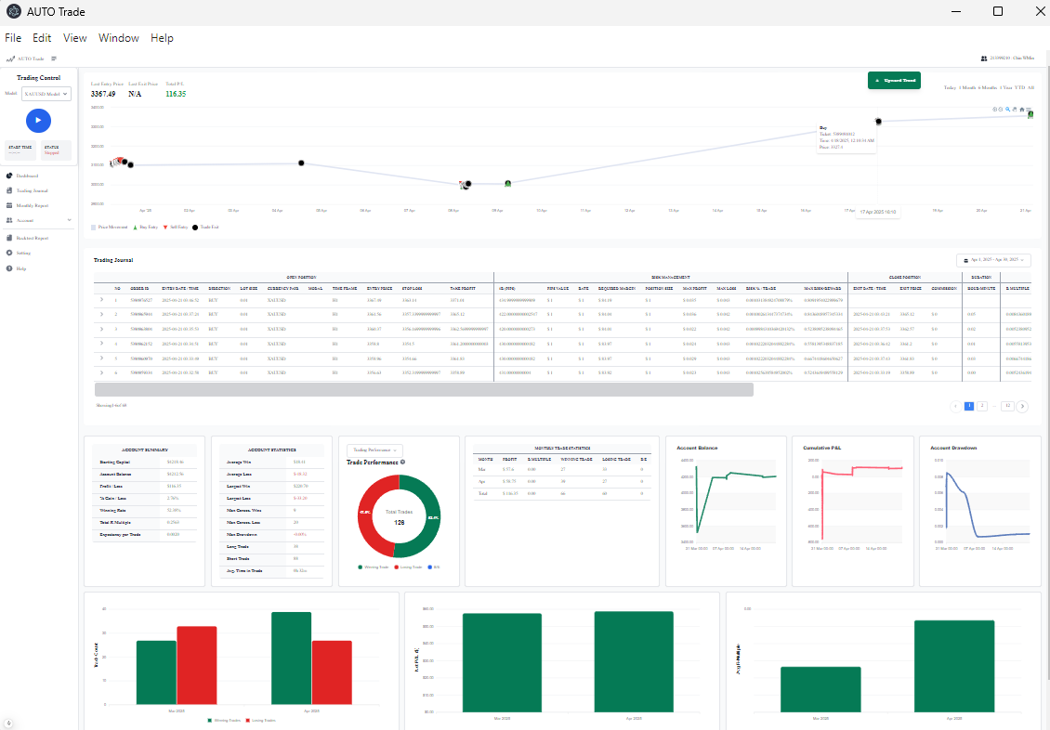

Figure 16: Frontend dashboard pages.

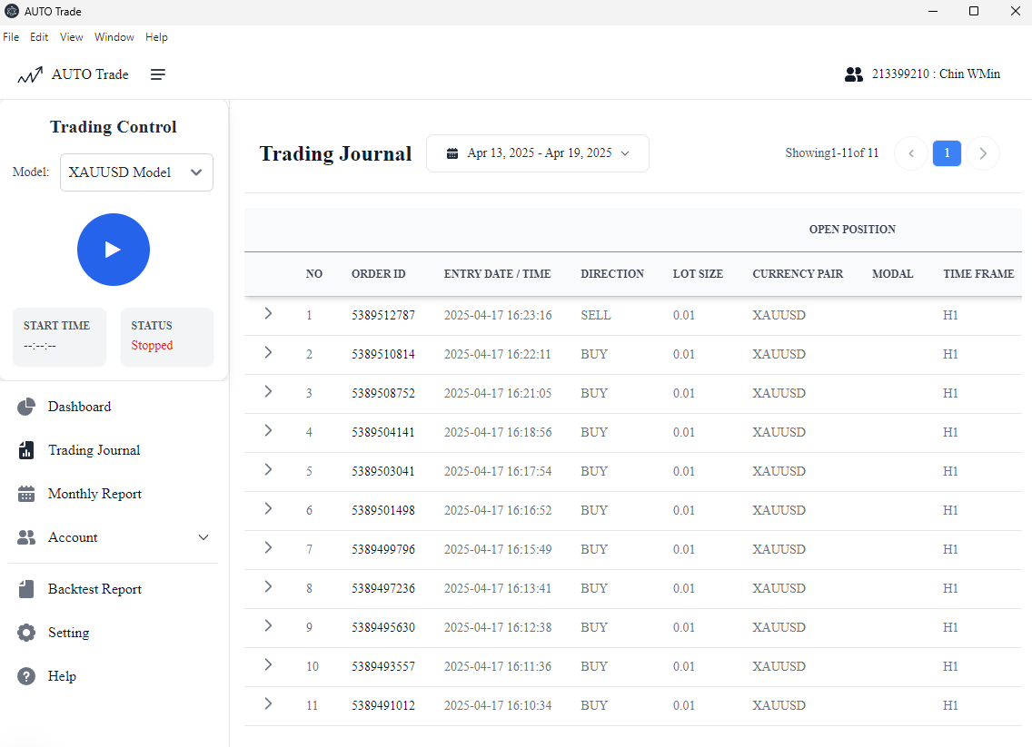

Figure 17: Frontend trading journal page.

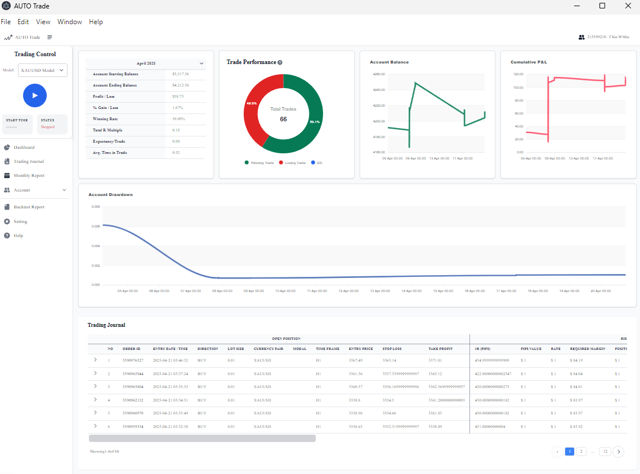

Figure 18: Frontend monthly report page.

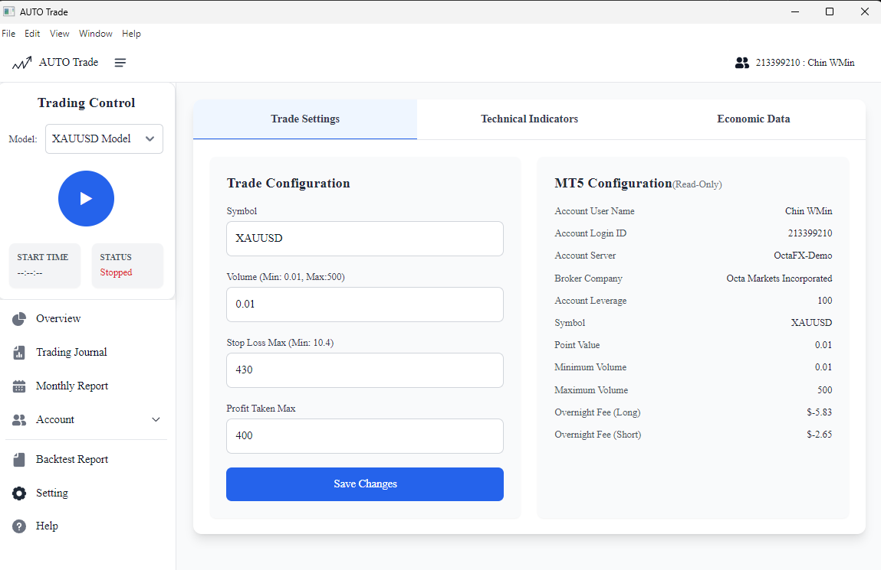

Figure 19: Frontend setting page.